SME AUTOMATION STARTER KIT

ADMIN USER MANUAL

1. Log in by providing credentials.

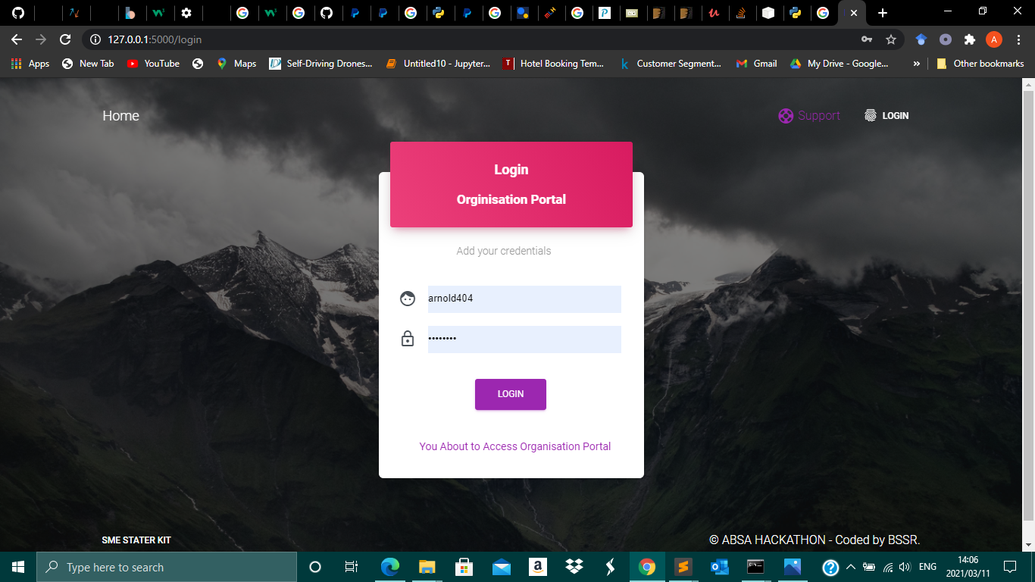

1. To add sales, click the add sales button, fill in the required fields and click submit.

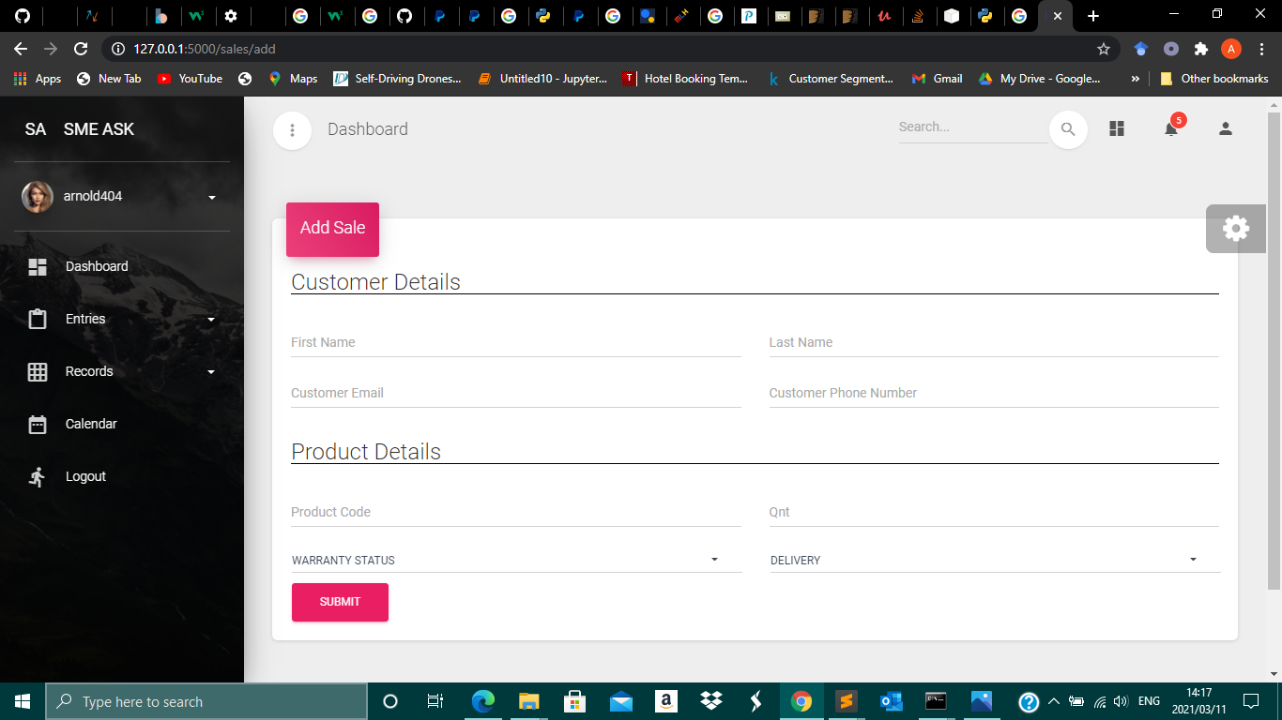

3. A confirmation message will pop up confirming the successful entry.

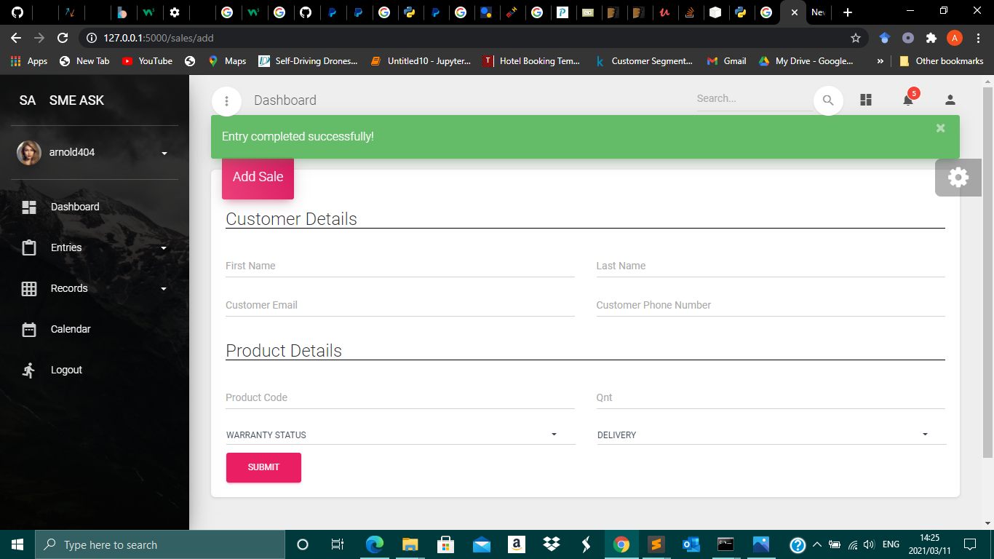

4. Sales can be deleted by clicking the red X button, click delete on the dialog box to confirm deletion of the record.

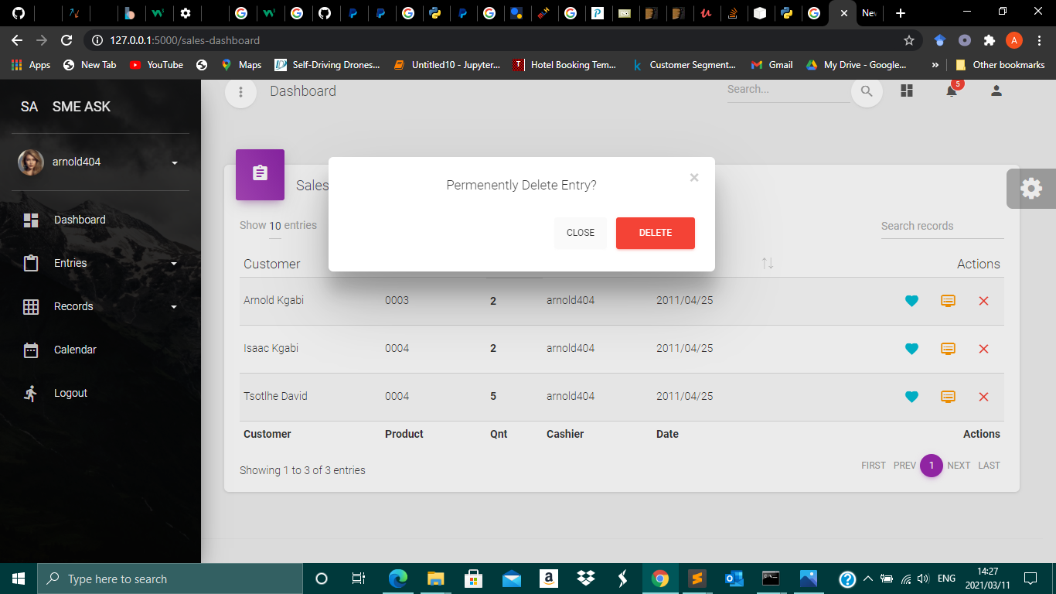

5. To update existing records, click the orange icon on the right.

